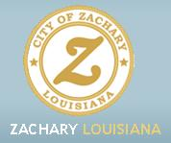

**Community Culture Inquiry**

1. **Physical Environment**
   1. **Spatial dimensions**
      1. **Boundaries, size, distribution, and regional position.**
      * State: Louisiana
      * County/Parish: East Baton Rouge
      * Area Code: 225
      * Located 14 miles N of Baton Rouge, LA and 70 miles NW of New Orleans, LA
      * Time Zone: Central
      * Zip Code: 70791
      * Latitude: 30.65; Longitude: -91.13
      * Elevation: 100 feet
      * Region: South
      * Climate----Annual Averages:
        + Temperature:

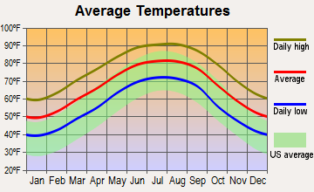

* + Precipitation:

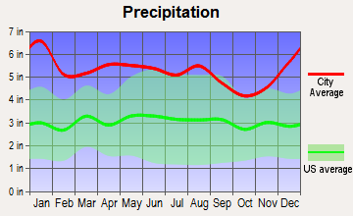

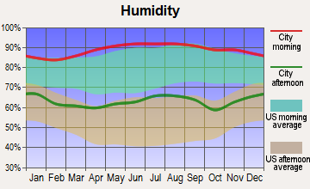

* + Rainfall:

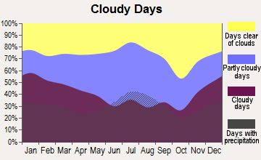

* + Snowfall:

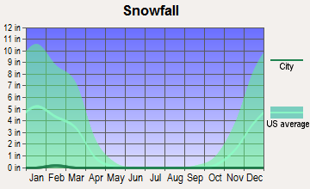

* + Sunny Days:

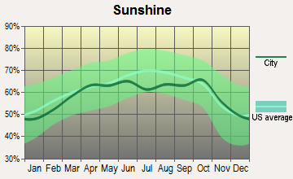

* + Prevailing Winds:

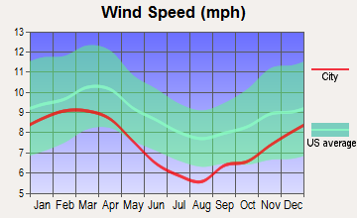

* + 1. **Geophysical and climate factors.** The climate of Zachary, Louisiana is typical of the southeastern region.  . On average, there are 218 sunny days per year in Zachary and there are 98 days per year with measurable precipitation. The average rainfall is 64 inches per year. Average snowfall is 0 inches. The July average temperature is 91 degrees while the January low averages at 41 degrees. The average humidity for the city is higher than the US average, which is to be expected. The wind speed of Zachary is below the national average. Zachary has an increased tornado activity rate when compared to the State of Louisiana. Streams in the area include Copper Mill Bayou, Black Creek, and Indian Bayou which are all considered great for fishing.



* + 1. **Land use.** The Zachary Youth Park, located at 1650 Mt. Pleasant Road provides facilities for baseball, softball and football for children, a half-mile walking track and two soccer fields.  The youth park is located on thirty-three acres with large pecan and oak trees for shade.  It has six baseball fields and three softball fields, as well as two covered batting cage areas and an indoor facility.  The indoor facility  houses three batting cages, two pitching lanes, large locker rooms and a trainer facility.  The park is open to the public including  picnic areas located throughout.  Zachary also has a top rated golf course, Copper Mill Golf Course. The golf course opened in 2003 and has received a number of honors and awards. In 2004, Golf Digest named it one of the "Best New Affordable Public Courses in America.'' Copper Mill was also named one of the "Best Courses in the State'' in 2005, and in 2006 received a 4-Star rating for "Best Places to Play.'' In 2007-2008, Golf Digest awarded it the prestigious Architecture Award as the "Best Course in Louisiana.'' Zachary is also home to Beaver Creek Golf Course which is an 18 -hole course that is open to the public located on 1100 E. Plains-Port Hudson
    2. **Housing.** The housing in Zachary ranges all the way from million dollar homes and subdivisions such as Copper Mills Golf Club to trailer parks. Between the months of November 2012 and January 2013, the median price of a home was $172,500. In 2006, the average property sales tax was $500. As of 2009, the mean price of detached houses in Zachary was $162,112, the mean price of townhouses or other attached units was $72,324, the mean price of 5-or-more-unit structures was $201,116, and the mean price of mobile homes was $111,089. In addition to neighborhoods and homes, there are also several living situations for the elderly. Lane Memorial Hospital Geriatric Ltc is a nursing home in Zachary, LA that provides patients with skilled nursing care as well as private or shared accommodations. Due to the fact that Zachary is a fairly small city, the residents of Zachary should be able to reach many of the available parks quite easily. Additionally, behind the apartment complex shown below there is BREC Park for the residents to take advantage of, and within the Copper Mills neighborhood there are multiple recreational opportunities to utilize. The most common ways that Zachary home owners heat their homes are:

• Utility gas (50.7%)

• Electricity (45.9%)

• Bottled, tank, or LP gas (2.2%)

• Wood (0.9%)

The most common ways that Zachary apartment renters heat their homes are:

• Electricity (60.1%)

• Utility gas (34.4%)

• Bottled, tank, or LP gas (3.4%)

• No fuel used (1.3%)

• Wood (0.8%)

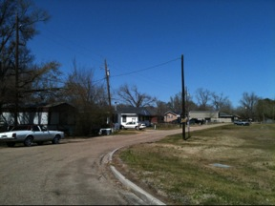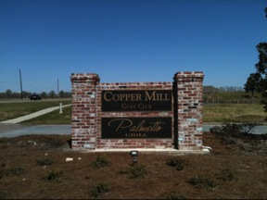

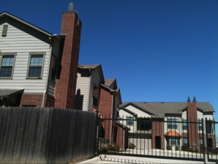

* + 1. **Transportation.** Transportation in Zachary is primarily confined to individual cars.  As many of Zachary’s residents work outside of town—such as Baton Rouge—the majority of its population commutes via car.  There is one East Baton Rouge bus that runs from Baton Rouge into Zachary, but its schedule is primarily early morning/late night, so it is not a reliable source of transportation.  In November 2012, the city of Zachary took ownership from the state of portions of La. 64, Old Baker Road, and East Central Avenue.  With the close to $7 million, Zachary plans on building a by-pass around the town in hopes that it will alleviate some of the traffic.  The most common way of getting in and out of Zachary is by taking the Baker exit and going through Main Street into Zachary.  The second way of getting into and out of Zachary is by taking the Old Scenic Hwy exit and going the “back way” into Zachary.  Eight percent of the population carpool to work, and the average time for commuting is 29 minutes.  In terms of getting to work, 88% drive a car alone, 1% take a bus or trolley bus, 0% take a streetcar or trolley car, 0% take a bicycle, 1% walk, 1% have other means of transportation, and 1% work at home.  The current average gas price in Zachary is $3.30 per gallon.

There are currently 44 FM radio stations that serve the city of Zachary, and 29 Am radio stations.  The FM radio stations are as follows: KPAQ 88.1, KPCP 88.3, WJFM 88.5, WRKF 89.3, WPAE 89.7, KLJG 90.1, WBRH 90.3, WJVI 90.9, KSLU 91.1, KPAE 91.5, WPEF 91.5, KLSP 91.7, WWRA 91.9, WRKN 92.3, WBKL 92.7, KRDJ 93.7, WEMX 94.1, WTQT 94.9, KRVE 96.1, WTGG 96.5, WHYR 96.9, WBRJ 97.3, WDGJ 98.1, KXKC 99.1, KTDY 99.9, WTGE 100.7, WYNK 101.5, WFMF 102.5, WRQQ 103.3, KLWB 103.7, KVDU 104.1, WNXX 104.5, WKJN 104.9, KYPY 104.9, KSLO 105.3, KDDK 105.5, KQXL 106.5, WHMD 107.1, WBRP 107.3, WAZA 107.7, KHXT 107.9.

The AM radio stations are as follows: KTIB 640, WFNO 830, WUBR 910, WAKK 980, WCKW 1010, WAPF 1140, WJBO 1150, KNEK 1190, WLRO 1210, KSLO 1230, WMIS 1240, KANE 1240, WHNY 1250, KBRH 1260, WIBR 1300, KVOL 1330, KNIR 1360, KPYR 1380, KFRA 1390, KFPR 1400, KPEL 1420, KMRC 1430, WNAT 1450, WXOK 1460, KCLF 1500, KFXZ 1520, WPFC 1550, WABL 1570, KKAY 1590.

There are a variety of social marketing companies available that serve the Zachary area, such as Bacon Social Media and Brandskin Media, but these are all located in Baton Rouge and not Zachary.

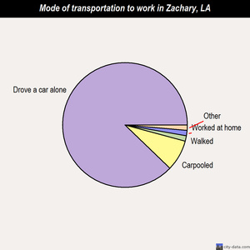

* + 1. **Communication.** Within the city of Zachary are many forms of communication from radio stations, television, newspapers, local magazines, and websites for individuals and businesses.  Some popular radio stations are KQXL 106.5 FM, WJNH 107.3 FM, WNXX 104.5 FM, 98.1 FM, WYPY 100.7 FM, WYNK 101.5 FM, and WFMF 102.5 FM.  Some television news stations are WAFB Channel 9, WBXH-CA Channel 46, WBRZ-TV Channel 2, WVLA Channel 33.  The newspapers for Zachary are the Zachary Plaisman-News or online newspaper at ZacharyToday.com.  Since Zachary is so close to Baton Rouge, they also receive Baton Rouge media ad well.
    2. **Mental maps.** While Zachary is one of the fastest growing cities, locals are still able to keep up with the old and the new landmarks.  For example, the Historic Village, Lane Hospital, Sammy’s Grill, Zachary High School, BREC parks, and the cemetery are only a few that can be easily visualized by locals and newcomers.  Some notable locations in Zachary include Zachary Manor Nursing and Rehabilitation Center, Zachary Historic Village, Lane Rehabilitation Center, East Baton Rouge Parish Library Zachary Branch, Zachary Police Department - Records Clerk, Zachary Fire Rescue Station 81, Zachary Volunteer Fire / Rescue Station 80, Oakwood Village Adult Care Facility.  Local churches in Zachary are Rock Church and World Ministries, Lighthouse of Zachary, Jackson Chapel United Methodist Church, Grace Baptist Church, First Presbyterian Church of Zachary, Church of Christ, Redwood Baptist Church, New Hope Baptist Church, Little Star Baptist Church. Some popular cemeteries include Shaffer Cemetery, Azalea Rest Cemetery, Stanford Cemetery, Johnson Cemetery, Redwood Cemetery. Common landmarks like rivers, streams or bayous are Copper Mill Bayou, Black Creek, Indian Bayou. Along with many BREC park, there is also Lion Park.  Some Tourist attractions in Zachary are: East Baton Rouge Parish School Board - Schools- Northeast High School- Lib (Cultural Attractions- Events- & Facilities; 13700 Pride Port Hudson Road).  The most commonly used hotel isBest Western Zachary Inn (4030 Highway 19)   (See attached Mental Map)
  1. **Temporal**
     1. **Community history.** Darel Zachary was a wealthy crop and livestock farmer in the 1800’s. In 1883 the Illinois Central Railroad built a track through the farmer’s land.  Many of Zachary’s livestock were taken out by the passing trains. Frustrated, the farmer sold his 160 acre spread to George Brown for $100 and left the area. In years following, the town became a hub of trade and commerce. Cotton, dairying and livestock were the main local industries. The burgeoning community saw its first post office open in 1885, and Zachary was incorporated as a city in 1889. The first census in 1914 reported 419 residents. Zachary was the first city in Louisiana to elect a Republican as mayor in 20th-century Louisiana. Jack Louis Breaux, Sr., served as a part-time mayor from 1966–1978, and a full-time mayor under a home-rule charter from 1978 until his death in 1980.

Although historically labeled a rural community, Zachary has recently become a presence of major employers such as Georgia Pacific, ExxonMobil, and Lane Regional Medical Center. By 1980, the population had grown to 7,525 and since has more than doubled. The Zachary school district became independent from the East Baton Rouge Parish school district in 2003 and has ranked #1 in the state every year since 2005.  Zachary is one of Louisiana’s fastest growing cities and was recognized in 2012 by Family Circle Magazine as one of the 10 Best Cities and Towns for Families.

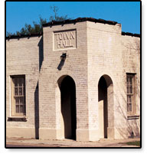

* + 1. **Cyclical population movement.** Zachary has many regular community activities. They change with the seasons and focus on family health. Every Saturday the Farmer’s Market is held on Main street. They also hold a City Council meeting open to the public every second and fourth Tuesday of the month. Entering into late spring outdoor athletic events begin. A youth baseball league as well as a youth softball league begins in May and plays through July. Age eligibility ranges from 4 to 16 years of age. There is also an adult softball league that runs from August to October. The city of Zachary takes great pride in its outdoor athletic facilities. They are well kept and have continuous improvements. The city is also very involved in fundraising and holds several events annually to raise money. For instance in March the Zachary Karate St. Jude Kick-a thon is held at no cost with donations only. During the holiday season there are many festivities to enjoy that are hosted by the city. For instance there is the Annual City of Zachary Open House has everything from the lighting of the tree to a performance of The Nutcracker. There is also an annual Christmas parade down Main Street. The pinnacle of all community events is the annual Z Fest. It is a music and arts festival that spans over three days. There is a carnival, food, and live entertainment for all ages. It is free to enter the festival. Zachary encourages community involvement and focuses on events that the entire family can enjoy year round.

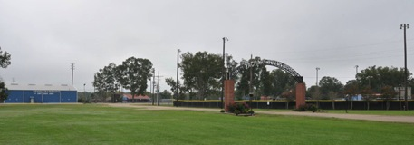 

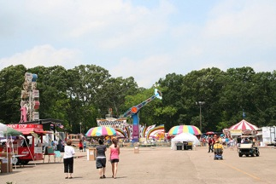

* + 1. **Economic cycles.** Zachary, LA is conveniently located 12 miles north of downtown Baton Rouge, allowing the people of Zachary easy access to and from a major city hub while having the unique ability to call a quaint, somewhat rural city their home. In the last few years, the image of Zachary as a strictly rural city has drastically changed, thanks to the “best kept secret of Zachary:” its’ school system. From 2003-2010, Zachary schools were consistently ranked #1 in the state of Louisiana. Zachary’s stellar school system has caused many families with school-aged children to move to Zachary for the school system alone. As a result of the influx of people, many new local businesses have sprung up around the city, new neighborhoods have been built to accommodate the people, and the hospital in Zachary has grown tremendously. Additionally, the city of Zachary and the Zachary Chamber have joined with the Louisiana Department of Economic Development and Baton Rouge Area Chamber in order to increase the possibilities of further economic growth in the city. Furthermore, Zachary has adopted a “Master Plan” to ensure economic growth in the city is tackled in the appropriate ways.
    2. **Psychological cycles.** Zachary has an annual Zachary Arts & Music Festival entitled Z-Fest that is hosted by the Zachary Chamber of Commerce and other local businesses. The festival is normally held during the spring and is open to the public with free admission. Local vendors are able to set up at the festival. The festival has music, games, rides and entertainment for all ages.

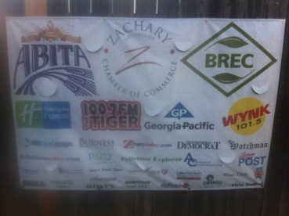

* + 1. **Cyclical crises.** Recurring crisis in the Zachary area center around weather conditions. Tornadoes are most prevalent during the spring. Zachary has a higher average for tornado activity  than Louisiana overall, and is 159% greater than the overall United States average.  Louisiana ranks first in the state and East Baton Rouge Parish ranks fifth in the nation for the number of repetitive loss and severe repetitive loss properties. Hurricane season officially runs from June 1 to November 30th each year. Overall the number of natural disasters in East Baton Rouge Parish, 20, is much greater than the US average of 12.

|  |  |
| --- | --- |
| **Federally Declared Disasters In East Baton Rouge Parish** |  |
| Hurricane Betsy | 9/10/65 |
| Hurricane Edith | 10/13/71 |
| Severe Storm & Flooding | 4/27/73 |
| Flooding | 2/23/74 |
| Heavy Rains, Tornadoes, Flooding | 6/6/75 |
| Severe Storm & Flooding | 5/20/77 |
| Severe Storm & Flooding | 9/20/78 |
| Severe Storm & Flooding | 5/2/79 |
| Severe Storm & Flooding | 1/11/83 |
| Severe Storm & Flooding | 4/20/83 |
| Severe Storm & Flooding | 6/16/89 |
| Tropical Storm Allison | 7/17/89 |
| Tornado, Severe Storm & Flooding | 5/3/91 |
| Hurricane Andrew | 8/26/92 |
| Severe Storm & Flooding | 2/2/93 |
| Tropical Storm Allison | 6/11/01 |

|  |  |
| --- | --- |
| **Table 9: Probability of Reoccurrence** |  |
| **Hazard** | **Probability** |
| (Thunderstorms/Lightning/High  Winds/Hail) | Highly Likely (13 federally declared events) |
| Tornadoes | Likely (2 federally declared events) |
| Dam and Levee Failure | See Note |
| Wildfires | Possible |
| Winter Storms | Possible |
| Drought | Highly Likely |
| Earthquake | Unlikely |
| Land Subsidence | See Note |

1. **Population of the Community** 
   1. **Total Population**.

* Total population of Zachary, Louisiana: 15,329. A review of population trends shows a 54% increase since 1990 and 33% since 2000.
* Population density: 602 per square mile
* Changes in population size (over past 10 years): There was a 54% change in 1990. Between the years of 1990 and 2000, there was a 33% change in population.
* Seasonal population changes: A local source reports that college students that attend college out of the area (LSU, ULL, and out of state universities) generally use the summer time and holiday breaks as time to come home to their families, thus resulting in a slight increase in population during these times.
  1. **Temporary subpopulations.**
* Commuters: These individuals enter the community on a daily basis to commute back and forth from their jobs. This results in an increase in traffic congestion and volume.
* Students: These individuals enter the community during holiday breaks and summertime for home visits.
* Construction Workers: The community is currently undergoing construction to the roadways due to an increase in tourism and traffic volume. These workers come from other areas and reside within the Zachary area until their job duties are complete.
* Tourism: Tourism has increased due to the widespread success of the school system and the construction of the new Audubon Bridge that dwindles between Pointe Coupee Parish and West Feliciana Parish. This bridge leads to Highway 61, which provides a direct route into the Zachary community.
  1. **Biological, ethnic and racial composition.** According to census.gov the total white population of 5,309, out of the male population of (2,470), 178 people had less than a high school education, 911 people had a high school diploma or equivalent 727 had some college and 654 had a bachelor degree or higher whereas the white female population totaled 2839. Out of that population 188 women had less than a high school diploma, 841 had high school diploma, 1091 had some college or associate degree and 719 had bachelor degrees or higher.

The African American population totaled 3358, the male population totaled 1,493. Out of that demographic 205 had less than a high school diploma, 648 had a high school diploma or equivalent, 345 had some college or associate degree, and 295 had a bachelor degree or higher. The female African American population totaled 1865. Out that population 187 had less than a high school diploma, 574 had a high school diploma or equivalent, 486 had some college or associate degree and 618 African American women had bachelor degrees or higher.

|  |  |
| --- | --- |
| **Zachary, LA MARITAL STATUS** | |
| Never Married | 2,752 |
| Now Married | 7,199 |
| Separated | 439 |
| Widowed | 734 |
| Divorced | 822 |

|  |  |  |
| --- | --- | --- |
| **Zachary, LA Population Diversity** | | |
| Race | Title Elements | # People of this race |
| White |  | 9,378 |
| Black |  | 5,531 |
| American Indian, Eskimo, Aleut |  | 43 |
| Asian or Pacific Islander |  | 125 |
| Other |  | 252 |
| Hawaiian or Pacific Islander |  | 2 |
| Hispanic |  | 247 |

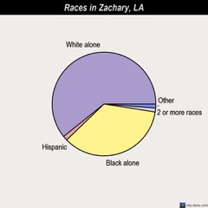

* Races
  + White alone—(60.7%)
  + Black alone—(35.3%)
  + Hispanic—(1.5%)
  + Two or more races—(1.2%)
  + Asian alone—(0.8%)
  + American Indian alone—(0.3%)
  + Other race alone—(0.1%)
  + Native Hawaiian and Other Pacific Islander alone—(0.01%)
* Ancestries
  + United States (15.8%)
  + French (8.4%)
  + Irish (7.3%)
  + German (5.9%)
  + English (4.5%)
  + Italian (3.8%)
  1. **Occupation, income and education level.** 
     + Management, business and financial operations           9.76 percent
     + Professional and related occupations                          18.36 percent
     + Service                                                                         14.01 percent
     + Sales and office                                                           27.61 percent
     + Farming, fishing and forestry                                          .60 percent
     + Construction, extraction and maintenance                  12.81 percent
     + Production, transportation and material moving        16.85 percent
  2. **Residential and household characteristics.** Growth and development within Zachary’s housing has increased significantly over the past 10 years.  With the increase in school district rankings, more families are moving to Zachary to ensure a better educational foundation for their children.  This has increased the demand for houses with enough room for parents and small children, rather than apartment complexes.  Thus when driving around Zachary, there are hardly any apartments to be seen.  There are also more families per household instead of individuals.  The majority of houses fall within the price range of $50,000-99,999.

1. **Social Organization of the Community**
   1. **Community institutions**
      1. **Economic.** With the ever growing economy, Zachary are seen some drastic economic changes over the past ten years.  Sixty-three point two six percent of population 16 years and over is in the active work force in Zachary, Louisiana and 87.79% of the over 16 years age group commute to work by car, truck, or van or drive alone.  Among them 29.87% are females aged 16 and over. As far as public transportation, there is hardly any as less than 1 percent of people use it. The residents that work at home only make up about 1.39% of the work force. The total population of Zachary, Louisiana is eleven thousand, two hundred and seventy-five people. The median household income in Zachary, Louisiana is forty-nine thousand, six hundred and sixty-nine dollars. Management, professional, and related occupations make up 28.82% of all occupations.  The Zachary population is involved into construction, extraction, and maintenance occupations that make up 12.19%, 27.77% of population are in sales and office occupations. Production, transportation, and material moving occupations account for 16.61% of occupations. Zachary, Louisiana median household income is $49,669. On an average, male full-time, year-round workers, receive forty-five thousand, ninety-two dollars, female full-time, year-round workers, are paid $25,143.
      2. **Government, politics, and law enforcement.** The Zachary Police department is located on Main Street, the main street running through town. There is a city court on main street as well, employing one judge, a city attorney, a city prosecutor, and a probation officer. The city contains one jailhouse on main street which is a holding facility designed to hold arrestees temporarily. Once the arrestees are incarcerated, they are transferred to the East Baton Rouge Parish prison. The Zachary police department has jurisdiction only within the city limits of Zachary itself. In order to be hired as Zachary’s City Attorney, the candidate must have at least 5 years experience in the practice of law. Similarly, in order to be hired as Zachary’s City Prosecutor, the candidate must have a least 5 years experience in the practice of law. Police officers are elected by qualified electors of the city for a 4 year term, and they can be eligible for reelection. The head of the fire department, or the Fire Chief, must have a minimum of 5 years experience in fire protection with 3 years of experience in command or supervisory positions, and must have completed local, state, or national fire protection training school.
      * City Mayor: David Amrhein
      * Chief of Police: David McDavid
      * Assistant Police Chief: Darryl Lawrence
      * Captain of Uniform Patrol-Captain Randy Aulds
      * Captain of Criminal Investigation Division and Internal Affairs-Captain James Sullivan
      * Councilman Francis Nezianya - District 1
      * Councilman Brandon Noel - District 2
      * Mayor Pro Tempore Councilman John Coghlan - District 3
      * Councilman Dan Wallis- District 4
      * Councilman Tommy Womack- District 5

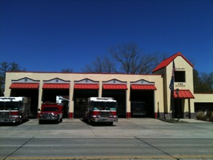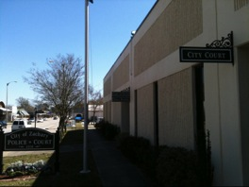

* + 1. **Domestic.** In the domestic households it can be seen that majority of houses are owner occupied.

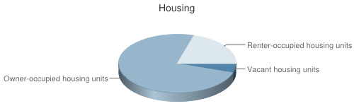

There are 3,066 family households in Zachary, La. Among those family households are 1,666 with children of their own who are under 18 years.  Of the 3, 066 family households 2,310 are married couple families and 1, 212 of the married couples have children of their own under 18 years.  There are only 597 households with only a female present, no husband, and of those there are 361 who have children under 18 years.  The remaining households are not families but rather nonfamily households.

* + 1. **Religion.** Zachary is a town grounded in religious beliefs. In the almost 24 square miles that make up Zachary, there are 69 notable churches. The majority of the residents are Catholic and shortly behind in popularity are the Baptist churches. Religious groups such as Islam and Eastern religions make up a small minority.

|  |  |  |
| --- | --- | --- |
| **Religion** | **Zachary, LA** | **United States** |
| **Percent Religious** | **67.46%** | **48.78%** |
| **Catholic** | **22.35%** | **19.43%** |
| **LDS** | **0.87%** | **2.03%** |
| **Baptist** | **20.58%** | **9.30%** |
| **Episcopalian** | **1.34%** | **0.63%** |
| **Pentecostal** | **1.19%** | **1.87%** |
| **Lutheran** | **0.41%** | **2.33%** |
| **Methodist** | **5.32%** | **3.93%** |
| **Presbyterian** | **0.97%** | **1.63%** |
| **Other Christian** | **13.28%** | **5.51%** |
| **Jewish** | **0.23%** | **0.73%** |
| **Eastern** | **0.58%** | **0.53%** |
| **Islam** | **0.35%** | **0.84%** |

* + 1. **Education.** The Zachary School district has steadily excelled since the city has separated from the East Baton Rouge Parish School system, which also correlates to the growth of the Zachary population. Zachary has been named the number 1 school district in the State of Louisiana for 8 years according to the Zachary chamber of commerce 2013 annual membership directory. Once Zachary became its own school district, the community of Zachary voted to approve a $129 million dollar construction bonds. Zachary has 8 schools that the district funds. Zachary Early Learning Center is for Pre-K age children. In 2013 the Zachary school district opened its 8th school, Rollins Place Elementary which is for first and second graders. The school cost the district $18 million dollars to complete the 105,000 square foot facility and can hold up to 1,000 students. The district believes in funding their school system. The district in 2011 opened an $8 million visual and performing arts complex that can be used by the community as well for certain events. Zachary separated from the East Baton Rouge Parish school system in 2003 and is now governed by the Zachary Community School Board. The school board is made up of nine members, one member to represent each of the nine districts within the school system. Scott Devillier is the school board Superintendent.

The Zachary school system is the fastest growing district in the state and has been ranked as #1 in the state for eight years in a row. The public schools consist of one preschool, three elementary schools, one middle school and two high schools. The Zachary Early Learning Center is for preschool aged children. Northwestern Elementary, Copper Mill Elementary and Rollins Place Elementary make up schools for children kindergarten through fifth grade. Northwestern is the only middle school; Zachary High School and Port Hudson Career Academy are for grades nine through twelve. In March 2013 The Zachary Community School Board voted to incorporate Port Hudson into the Zachary High School community. Port Hudson is available for students who prefer a smaller learning environment, has “alternative students” who have been suspended or expelled from school, and serves as the district’s College and Career Academy. It simultaneously offers specialized emotional and social needs. The special needs students will stay at the facility. However, the school itself has been given a grade of F twice recently in the national rankings. Typically, because the students who have either selected the smaller learning environment or been suspended or expelled do not achieve high scores on state tests. Their scores now will be counted among those of all high school students.

Zachary has one state-accredited private school, Trinity Christian Academy. The private school serves grades 5-12. The total student population for 2013 is approximately 4,925 from kindergarten through 12th grade.

There are three public libraries for Zachary residents. There is the Zachary Branch Library, Pride Cheneyville Library and lastly the Zachary Library referred to generally as simply “Library.”

A specific program focused on insuring Zachary School District teachers have effective teaching skills is the ZIP program. The Zachary Induction Program (ZIP) is a three-year induction program for new teachers. To successfully complete the ZIP, new teachers must achieve three “Satisfactory” ratings on teacher performance evaluations.

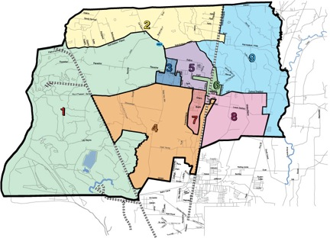

* + 1. **Recreation.** There are many parks located within the city that are very well-maintained and open to the public. BREC has a park site located in Zachary, and there are several baseball/softball fields. For such a small town, there is a heavy influence of public parks and baseball fields. There is even a website devoted to the schedule of baseball practices and games for the youth of Zachary. In addition to the parks and fields, there is a local Farmer’s Market that meets every Saturday from 8 am – 12 noon. The local Farmer’s Market boasts farm products, jams, jelly, cakes, pies, and handmade crafts available for purchase. Finally, one of the most alluring aspects of Zachary is its’ historic district. Within the historic district are three houses, a barn, a carriage house, a pavilion, a Railroad Depot, the Old Town Hall with an adjacent fire house, an old movie theater, and the Zachary Bank. Though the historic district only spans 2 blocks, it provides a quaint image of small-town life from the 19th century through the 1960s.

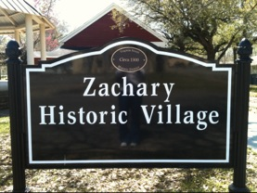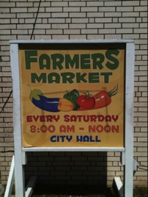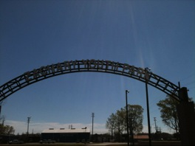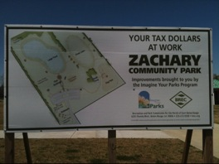

* + 1. **Voluntary.** The city of Zachary has many various types of voluntary organizations in the community. Some of the religious voluntary organizations are: Legendz Sports Academy, which is a Non-profit organization led by president Todd W. Hernandez; and Kidz Rock children’s ministry through The Rock Church in Zachary, and is led by children’s church directors Patrick and Christal Washington. In addition to meetings on Sunday and Wednesday nights, the children’s ministry organizes a Kidz Camp during the summer. A social voluntary organization in Zachary is the Zachary Newcomer’s Club, which is held at the Zachary Police Complex on the 3rd Thursday each month between the months of September and May. It is governed by a 13 member Board with five executive officers, elected by the membership in April. A political voluntary organization in Zachary is the Zachary Rotary Club, which meets weekly and is lead by rotary president Mark Marionneaux. Finally, two of the economic voluntary organizations in Zachary are the Zachary Food Pantry and Goodwill, which operate through donations given by the people of the city.
  1. **Horizontal stratification.** See page
  2. **Vertical stratification.** See page

**Community Health Assessment**

1. **Environmental Health**
2. **Outdoor air quality.** The air quality in Zachary is measured by an air quality measurement station and measures the condition or quality of air and pollutants and based upon relative conditions needed for healthy breathing. The lower the index value, the better the quality of air residents of Zachary will have. Depending on the number of ozone alert days, the EPA can ascertain the amount of pollutants in the air such as carbon monoxide, sulfur dioxide, particulates, lea and volatile organic chemicals.

Air Quality Index (AQI) level in 2010 was 31.2. This is about average. Carbon Monoxide (CO) [ppm] level in 2010 was 0.221. This is significantly better than average. Closest monitor was 13.3 miles away from the city center. Sulfur Dioxide (SO2) [ppb] level in 2010 was 1.93. This is better than average. Closest monitor was 11.2 miles away from the city center. Nitrogen Dioxide (NO2) [ppb] level in 2010 was 10.6. This is about average. Closest monitor was 4.6 miles away from the city center. Ozone [ppb] level in 2010 was 24.8. This is about average. Closest monitor was 4.6 miles away from the city center.  Zachary in the state of Louisiana has an air quality index of 16.8 which is based upon yearly reports compiled by the U.S. Environmental Protection Agency also known as the EPA.

1. **Surface-and ground-water quality.** Water quality in Zachary is 13 and like air, represents the quality of Louisiana's water supply based upon the following 15 indicators, fish consumption advisories, wetland loss, urban runoff potential, estuarine pollution susceptibility, conventional pollutant loads above permitted limits, population change, contaminated sediments, agricultural runoff potential, toxics, conventional pollutants source water for drinking water systems, designated use support, wetland and aquatic species at risk, toxic pollutant loads above permitted limits, hydrologic modification created by dams in this part of Louisiana.
2. **Food contamination.** With water contamination and decrease in water quality, there is potential for contaminated sediments, agricultural runoff potential, toxics, conventional pollutants source water for drinking water systems.  Should this water be used on plants and crops sold or eaten, there is risk for food contamination for the whole community.  There is a push for organic pesticides for local farmers but there are no specific statistics to state which foods are contaminated and toxic.
3. **Toxic substances and hazardous-waste management.**

* WM waste Management Company
* East Baton Rouge parish operates 31 ground water wells
* Sanitary Sewer Overflow (SSO) Control and Wastewater Facilities Program
  + Annual expenses for the City of Zachary for Toxic and Hazardous Waste management:

1. **Solid waste.** $693,000
2. **Water utilities.** $890,000
3. **Sewage.** $583,000
4. **Radioactive waste, chemicals and pesticides.** No information available.
5. **Noise pollution.** Zachary currently has road construction underway on Mount Pleasant Road. The workers are currently expanding the road and putting additional turning lanes for convenience. The road was only single lanes leading into and out of the city of Zachary. These turning lanes will make it easier to have appropriate lanes just for turning onto Highway 61 to head into Baton Rouge or onto 61 heading into the New Roads or St Francisville area. There is also noise pollution due to transport along Main St, which is the busiest street in the community. It is important to investigate noise pollution since it can contribute to hearing loss, as well as, stress reactions, accidents, hypertension, irritability and cardiac disease.

[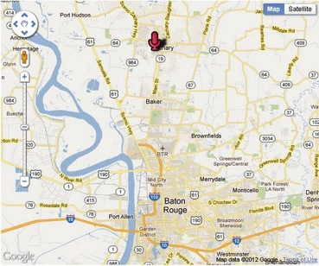](http://www.batonrougehousingreports.com/2012/04/east-meadow-subdivision-zachary-louisiana-april-2012-audio-update/)

1. **Disease vectors.** 
   * + Mosquitoes (i.e. West Nile Virus)
     + Ticks
     + 2009----H1N1 Virus (“swine flu”)
     + Hazardous occupational environments (i.e. plant workers with exposure to hazardous or radioactive materials)
2. **Preparedness.**

* East Baton Rouge Parish Emergency Operations Plan (EOP)
* ANNEX D: Appendix Emergency Stop Locations
* Town of Zachary Police Department 4510 Main Street Zachary, Louisiana
* East Baton Rouge Parish Sheriff's Office 300 North Boulevard Baton Rouge, Louisiana
* Office of State Police Troop "A" 17801 Highland Road Baton Rouge, Louisiana
* Office of Homeland Security and Emergency Preparedness of East Baton Rouge Parish – East Baton Rouge Parish Homeland Security and Emergency Preparedness Emergency Operation Center----provides emergency information and planning for natural disasters, school closures, evacuations, emergency stop locations, shelters, emergency medical needs, and emergency operations plan guides.
* Disaster Management Solutions

1. **Crime.** Zachary crime statistics from 2000 to 2010 have steadily decreased. Compared to the state and national averages, Zachary has dramatically decreased each year. Crime increased in Zachary slightly from 2011 to 2012. Mayor Arnheim, in multiple published interviews has attributed this increase in overall crime to an increase in population.

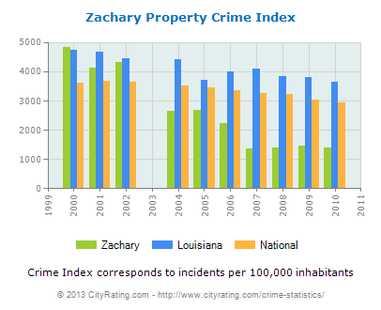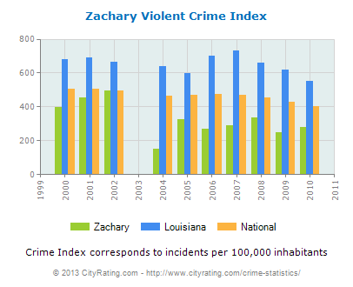

|  |  |  |
| --- | --- | --- |
| **Crime** | **2011** | **2012** |
| Larceny | 258 | 368 |
| Burglaries | 10 | 26 |
| Drug Arrests | 92 | 99 |
| Assault | 110 | 127 |
| Rapes | 1 | 4 |
| Adult Arrests | 810 | 1003 |
| Juvenile Arrests | 56 | 57 |

1. **Accidents.** Fatal car accidents have progressively decreased. The most recent data found is the fatal car accidents in Zachary in 2009. There was one motor vehicle accident involving a fatality in 2009. This is compared to the 2008 total of two and the 2007 total of four.
2. **Homes and communities.** Housing in the community ranges from rural homes on large parcels of land, to upper class pre-planned communities such as Copper Mill. Mobile homes are seen frequently throughout the area but are not limited to one section of Zachary. There are several apartment complexes within Zachary. The majority of Zachary residents own their home. Although there are communities catering to the elite as well as low-income communities, the majority of the communities are middle class such as Ravenswood and Windsor. According to the city of Zachary website, the predominant housing type created between 1990 and 2000 was detached, single-family homes.
3. **Community Buildings.** Zachary is in compliance with OSHA standards for occupational safety and health by way of obtaining a mandatory crane and rigging certification before operating heavy machinery.  By 2014, all those wishing to operating a crane on a construction site must first undergo “mobile crane certification and training.”  This new federal law was written in 2010, and all states were given 4 years to make the changes to comply. The mayor has the right to enlist the services of the chief building inspector at any time, in order to inspect a building’s structural safety.  According to the division II, section 14-119 in the Zachary code of ordinances, “The duties of the chief building inspector and such assistants as may be authorized, shall be to inspect all electrical construction, installations and equipment of whatever character and type for the inside and outside of buildings. They shall have the power to order removed, repaired or rebuilt, any construction, installation or equipment when in their judgment life or property, or both, will be better protected thereby, and shall enforce the strict compliance of all laws governing the use of electrical energy or construction applying within the city.”  The East Baton Rouge Parish smoking law, as of 2005, says that people can smoke 25 feet away from a non-state building, within a building that serves alcohol, but not at a city-owned park such as BREC or at a golf course.  The law is slightly unclear, but if caught smoking in a non-designated area, smokers could face up to 30 days in jail and a $500 fine.
4. **Energy management.** Zachary implements the use of a wide variety of energy sources such as renewable energy (wind, solar, tides, rain, geothermal heat, biofuels, and hydropower), electricity, gas, and oil. There are also “green initiatives” in Zachary that aim at creating eco-friendly energy sources such as Structure Green. The various types of energy companies available are: Baton Rouge Renewable Energy, Global Energy Technologies, Devon Energy, Thermo Guard Insulation LLC, Browning-Ferris Industries, Johnson Electric Company, Emsco Plant, and Structure Green.  The gas stations in Zachary are: Texaco, Shell Service Station, Murphy USA, BP, Circle K, and On the Run.  Recently, the city of Zachary sent out a public announcement letting its’ residents know that a gas pipeline had been buried underneath the gas service area, in order that consistent energy be provided to the customers.
5. **Global health.** It seems that due to the Zachary public school system being one of the best in the greater Baton Rouge area, families have a tendency to migrate to the city of Zachary in order to put their children through a quality public school system. As children are unable to attend public schools in a parish outside of that which they reside, more families are choosing to relocate for the sake of their child’s education. There are very few (if any) international persons/groups in the community.
6. **Population Health**
7. **Infectious diseases Infectious Diseases.** East Baton Rouge Parish maintains that the highest rate of infectious diseases are syphilis, chlamydia, gonorrhea, and tuberculosis. HIV/AIDS is also an infectious disease that ranks highly in EBR parish.
8. **Chronic Diseases.** Diseases that are highest in the East Baton Rouge parish population are heart disease, cancer, cerebrovascular disease and diabetes. Most of these chronic diseases stem from the large amount of residents with obesity.
9. **Chronic disability.** In East Baton Rouge Parish, it is estimated that 72,553 people ages 5 and older (19 percent) have a disability. 5-15 Years: For every 1,000 children ages 5-15 in East Baton Rouge Parish, it is estimated that 66 have a disability. This contrasts to almost 58 in 1,000 for the United States and nearly 70 in 1,000 for Louisiana. The most noticeable factor of disability in this age group is the high percentage of people reporting a mental disability. This trend is prevalent in both the U. S. and Louisiana, where according to Census 2000, nearly 8 out of 10 children who report a disability report a mental disability (difficulty in learning, remembering or concentrating). This is greater than any of the other reported disabilities in this age group. Of the 52,832 students in public schools in East Baton Rouge Parish, 10.5 percent (5,535) were children with disabilities.12 16-20 Years: In East Baton Rouge Parish, it is estimated that 151 out of 1,000 people 16 to 20 years of age report a disability. This compares to almost 133 in 1,000 for the United States and nearly 144 in 1,000 for Louisiana. The prevalence of disability for this age group is over two times the rate for the 5-15 age groups. While mental disability is the largest reported disability, the prevalence in the U.S. has declined from 8 in 10 in the 5-15 population to just less than 3 in 10 in the 16-20 population. In East Baton Rouge Parish of the people 16-20 years of age who report a disability, 2,259 report a go-outside-the- home disability and 2,930 report an employment disability. For every 1,000 adults ages 21-64 in East Baton Rouge Parish, it is estimated that 193 have a disability. This compares to 192 in 1,000 for the United States and 221 in 1,000 for Louisiana. For the 21-64 age groups in both Louisiana and the U.S., the most reported disabilities are physical disability, followed by mental disability. In East Baton Rouge Parish, for the 65 and older population, 435 people in 1,000 report a disability compared to the state rate of 481 and the United States rate of 420.19 Physical disabilities are the leading type of disability in the elderly population. The high rates of physical disability intensify and compound the problem of going outside the home. In East Baton Rouge Parish, it is estimated that 337 people out of 1,000 ages 65-74 years report a disability, compared with 558 people ages 75 and older.

* Prevalence of Disability Among Persons 5 Years and Older By Disability Type

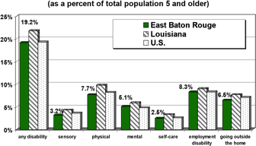

|  |  |  |  |
| --- | --- | --- | --- |
| **Disability Prevalence by Race, Age and Sex**  **Rate per 1,000 Population** | | | |
|  | **East Baton Rouge** | **Louisiana** | **U.S.** |
| All Persons 5 and Older | 191.7 | 217.5 | 193.4 |
| White  Black  Other | 169.1  224.5  198.4 | 205.7  242.0  217.9 | 185.3  243.3  195.7 |
| Male  Female | 193.6  190.0 | 224.0  211.7 | 196.1  190.9 |
| 5-15 Years  16-20 Years  21-65 Years  65-74 Years  75 Years and Older | 66.4 151.4  193.2  337.2  557.6 | 69.7 144.2  221.1  387.3  606.6 | 57.9 132.9  192.0  322.7  535.9 |

1. **Behavioral and Mental health** There are several options available for residents of Zachary to choose from in terms of behavioral and mental health services. Behavioral health services available are through Lane Behavioral Health Services and Progressive Partial Hospitalization Program, Mental Health services available is the Matters of the Mind company owned by psychiatric nurse practitioner Brittany Smith, and there are currently 16 other behavioral and mental health therapists who serve in the community.
2. **Maternal, infant, and child health.** There are currently four Ob/Gyn doctors available to the Zachary area with locations at Zachary Ob/Gyn Associates and Bayou Regional Women’s Clinic. Additionally, there are three pediatricians with practices in the Zachary area. In November, 2012 a new Women, Infant, and Child Health and Wellness Center opened up on Main Street called Southeast Community Health Systems. As of 2010, the number of stillbirths reported in the state of Louisiana was 211, down from 367 the year before. In East Baton Rouge Parish, in the year 2009 there were 12 babies born to mothers <15 years of age, 783 babies born to mothers within 15-19 years of age, 77 babies born to mothers within 35-39 years of age, and 22 babies born to mother 40-44 years of age. Clearly, there are a considerable amount of babies born to teenage mothers in EBRP. WIC is available through a statewide system of 112 clinics located in parish health units and contract local agencies. The statewide participation in the WIC Program during state fiscal year 2010 was approximately 155,100 women, infants, and children representing a 5.5% increase in participation from fiscal year 2009. The WIC Program in Louisiana is 100% federally funded by two grants from the United States Department of Agriculture (USDA): a Food grant and a Nutrition Services and Administration grant. The Program received $131,995,266 in federal funding during state fiscal year 2010. Of that total, The Commodity Supplemental Food program CSFP is also 100% federally funded through a grant from the USDA. This program provides monthly food boxes primarily to senior citizens, and in addition to that serves pregnant women, breastfeeding and postpartum women, infants, and children up to 6 six years of age. The caseload allocated by the USDA to Louisiana CSFP for federal fiscal year 2009 was 74,689 individuals per month, of whom approximately 93% are senior citizens.
3. **Early, middle childhood, and Adolescent health.** Within Zachary the obesity rate is 27.7% while Louisiana’s is 29%. While unable to find the leading cause of death in the city of Zachary,  the top leading causes of death in Louisiana for the ages of 1-14 are unintentional injury, homicide, suicide, heart disease, malignant neoplasms, influenza, pneumonia, congenital anomalies, heart disease, and diabetes. Also the preschool obesity rate is higher than the state’s average.  School’s are becoming active in the nutrition status of their students and forming a lunch menu provided for students with only balanced nutritional meals available.  Every Saturday there is a Farmer’s Market in which the city can purchase local and unprocessed produce and goods, thus giving Zachary residents an opportunity to eat healthier.



1. **Older adult health.** In East Baton Rouge Parish, for the 65 and older population, 435 people in 1,000 report a disability compared to the state rate of 481 and the United States rate of 420. Ages 21-64 Years by Disability Type\*(as a percent of total population 21-64 years) 98 People with Disabilities East Baton Rouge Parish Health Profile. (Source: U.S. Bureau of the Census, Census 2000.) \*Disability types are not mutually exclusive Source: U.S. Bureau of the Census, Census 2000. In East Baton Rouge Parish, it is estimated that 337 people out of 1,000 ages 65-74 years report a disability, compared with 558 people ages 75 and older. In the United States the prevalence rate is nearly 323 out of 1,000 for ages 65-74 and nearly 536 for ages 75 and older. In Louisiana, the rate is just over 387 for 65-74 years and Prevention and Services: Parish Councils on Aging (COA) programs directly address those issues associated with quality aging, offering a variety of services from volunteer opportunities to meals on wheels. COA centers also provide educational, social, and recreational activities and are a major provider of transportation services. Immunization programs at parish health units and community-based programs provide an easily accessible source of flu and pneumonia shots. Community centers, local health clubs, hospitals and YMCAs offer physical recreation and exercise such as mall-walking and formal exercise classes. For more information visit the Governor’s Office of Elderly Affairs at www.louisiana.gov or Eldercare Locator at 1-800-677-1116 [www.eldercare.gov](http://www.eldercare.gov).
2. **Lesbian, gay, bisexual, and transgender health.** [Capital City Alliance](http://www.ccabatonrouge.org/" \t "_blank). "Capitol City Alliance (CCA) is an all volunteer organization whose mission is to improve the quality of life for all lesbian, gay, bisexual and transgender people and our allies in the greater Baton Rouge area." [PFLAG Baton Rouge](https://www.facebook.com/groups/254767281208778/" \t "_blank). This is the facebook page for the local chapter of the Parents, Families and Friends of Lesbians and Gays national non-profit organization. [LSU Spectrum](http://www.lsu.edu/student_organizations/spectrum/pages/home.htm" \t "_blank). "Spectrum is a group intended for gay, lesbian, bisexual, transgender, and queer students; as well as their supporters. We are an alliance formed to increase awareness of the needs and concerns of LSU's GLBTQ community." [Metropolitan Community Church of Baton Rouge](http://www.mccbr.org/" \t "_blank). "MCCBR is a Christian Church that is open for all to worship as they are, Gay, Straight, Transgendered, Lesbian, Bi and others."
3. **Occupational safety and health.** Certain occupations require surveillance such as pesticides, chemical and plant exposures, etc. It is important safety be maintained since the majority of the male population works in careers that require heavy equipment use, chemical exposure, and safety hazards.

* Majority of males work in these areas:
  + Other production occupations including supervisors (10%)
  + Electrical equipment mechanics and other installation, maintenance, and repair occupations including supervisors (7%)
  + Law enforcement workers including supervisors (5%)
  + Metal workers and plastic workers (5%)
  + Other sales and related workers including supervisors (3%)
  + Building and grounds cleaning and maintenance occupations (3%)
  + Driver/sales workers and truck drivers (3%)

1. **Population health behaviors.**

* Alcohol, Tobacco, and Other Drug Use % of Student who “ever used.”



**0**

**%**

**10**

**%**

**20**

**%**

**30**

**%**

**40**

**%**

**50**

**%**

**%**

**60**

**%**

**70**

**80**

**%**

**90**

**%**

**100**

**%**

Chewing

Alcohol

Cigarettes

Inhalants

Hallucin-

Marijuana

Cocaine

Meth-



East Baton Rouge 1998



East Baton Rouge 2001

East Baton Rouge 2002

Louisiana 2002

**grades 6, 8, 10 & 12 combined**

**)**

**(**

* Women Needing Publicly Assisted Contraception Supplies and Service

**%**

**0**

**10**

**%**

**20**

**%**

**%**

**30**

**%**

**40**

**%**

**50**

**%**

**60**

**%**

**70**

**%**

**80**

**90**

**%**

**%**

**100**

**East Baton Rouge**

**U.S.**

**Louisiana**

**as a percent of all females ages 13 - 44**

31,770

304,270

16,776,730

* Leading and Actual Cases of Death in the United States, 2000

|  |  |  |  |
| --- | --- | --- | --- |
| **Leading and Actual Causes of Death United States, 2000** | | | |
| **Leading Causes**  **(as recorded on death certificate)** | | **Actual Causes**  **(underlying and/or contributing factors)** | |
| Heart Disease  Malignant Neoplasms (Cancer)  Cerebrovascular Disease (Stroke)  Chronic Lower  Respiratory Disease  Accidents (Unintentional Injuries)  Diabetes Mellitus  Influenza and Pneumonia  Alzheimer's Disease  Nephritis (Kidney Disease)  Septicemia (Blood Poisoning) | 30%  23%  7%  5%  4%  3%  3%  2%  2%  1% | Tobacco  Poor Diet/  Physical Inactivity  Alcohol Consumption  Microbial Agents  Toxic Agents  Motor-vehicles  Firearms  Sexual Behavior Illicit Drug Use | 18%  17%  4%  3%  2%  2%  1%  1%  1% |

* Prevalence of Adult Obesity



* Percentage of adults who do not engage in physical activity or exercise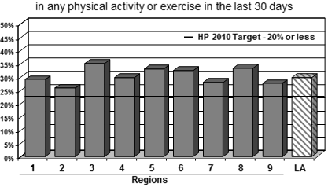

1. **Health Care Organization**
2. **Health Workforce such as:**
3. **Nursing.** Zachary offers nursing opportunities at Lane Medical Center, The Lake After Hours Urgent Care, all of the public schools within the city, as well as the previously listed nursing homes and assisted living facilities. Additionally, there are two outpatient surgical centers in Zachary: Zachary Surgical Center and Meridian Surgical Partners.
4. **Medical**. Medical personnel is needed in all above stated facilities. Lane Medical Center is the largest center requiring medical employees.
5. **Dental.** Zachary Residents have multiple dentist and orthodontist offices to chose from. Owens Family Dentistry, Dr. Mark, DDS, Endodontics of South Louisiana, and Dr. Jeffrey, DDS are a few of the most popular.
6. **Social work.** Social work is primarily performed around the medical needs of Zachary residents. Facilities such as Lane Medical Center and Lane Home Health seek out many social working professionals.
7. **Mental Health.** Progressive Health Center
8. **Nutrition.** There is one nutritionist located in Zachary - Chantelle Jones. However, Zachary does offer nutrition and fitness centers, such as: Snap Fitness, Spectrum Fitness, Anytime Fitness, and General Nutrition Center.
9. **Optical/Audiology.** There are three optical centers: Eye on the Ball Vision Clinic, Williamson Eye Center, and Eye Care and Surgery Center. There are two audiology centers: Ear, Nose, and Throat Medical Center, and Selective Hearing.
10. **Therapies, such as Physical, Occupational, Speech.** There are numerous physical therapy facilities in Zachary, such as Kleinpeter Physical Therapy, Moreau Physical Therapy, Physical Therapy and Hand Center, Lane Rehabilitation Center, Novacare Rehabilitation. There is one occupational therapy facility separate from the physical therapy facilities: Rivet Hand Rehabilitation Center. 6 speech therapists/pathologists and 1 speech therapy facility: Speech Therapy Interventions Inc
11. **Public Health Agencies**
12. **Health Departments.** Lane Regional Medical Center.
13. **Personal Health Care Agencies such as:**
14. **Hospitals (“health centers”).** Lane Regional Medical Center (Acute Care Hospitals, Government - Hospital District or Authority, provides emergency services.
15. **Nursing homes, extended care facilities, assisted living.** Zachary Manor Nursing and Rehabilitation Center, Lane Rehabilitation Center, Oakwood Village Assisted Living Facility.
16. **Home health agencies.** Lane Home Health an Affiliate of Lane Regional Medical Center, Destiny Home Health.
17. **Freestanding ambulatory facilities.** Lake After Hours (Urgent Care Center), Fresenius Zachary Crossroad Dialysis Center.
18. **Health Planning Agencies.** Available programs are available through Lane Memorial Hospital.
19. **Public Health Financing**
20. **Third Party payers**
21. **Commercial.** There are many different options for insurance coverage. In Louisiana, the majority of individuals with coverage are covered by an insurance plan offered through their employer. Health maintenance organizations, one type of insurance plan, are both insurers and health care providers. They accept responsibility for a specific set of health care benefits offered to customers and provide those benefits through a network of physicians and hospitals. In Louisiana there are currently 10 licensed HMO’s primarily composed of independent physicians practicing alone or in small medical groups operating in the state. In 2002 there were approximately 626,780 Louisiana residents, or 14 percent of the population, who were enrolled in HMO’s.
22. **Government.** Government-sponsored insurance programs include Medicaid, LaCHIP and Medicare. Each has a certain set of eligibility requirements and is targeted for a specific segment of the population. However, many services go unused because eligible children, adults and families are not enrolled either because they do not have the ability to find or get to a health care provider, or they are unable to navigate through the system. As a result, problems that might have required low-cost preventive care can become expensive and serious before insurance is accessed. Children are of special concern because of their vulnerability and dependency upon parents or other caregivers.
23. **Self-pay, charity.**

* Public Health Financing

**Insurance Coverage for Adults Louisiana Region 2 EBRP**

|  |  |  |
| --- | --- | --- |
| Uninsured Adults | 21.1% | 19.2% |
| Insured by Employer | 55.3% | 59.2% |
| Insured by LaCHIP/Medicaid | 4.5% | 4.0% |
| Insured by Military | 2.9% | 2.3% |
| Bought Insurance | 8.5% | 9.3% |
| Insured by Medicare | 4.1% | 2.7% |
| Insured by Former Employer | 4.4% | 4.5% |
| Insured by Someone Not Living in Household | 1.3% | 1.6% |

Source: DHH, Louisiana Health Insurance Survey, April 24, 2004

1. **Public Assistance.** Medicaid—In East Baton Rouge Parish almost 20 percent of the population (an estimated 82,559 people) are eligible for Medicaid. In Louisiana, Medicaid is administered by the Department of Health and Hospitals, Bureau of Health Services Financing. Medicaid is a primary source of preventive health care for medically vulnerable Americans such as, but not limited to, low income families, low-income seniors, and people with a disability. Medicaid covers a wide range of services including physician, hospital, laboratory, X-ray, and nursing home services. Optional programs cover services such as pharmacy and intermediate care facilities for the developmentally delayed. Medicaid services for children are offered through KIDMED. The program provides preventive health care for Medicaid-covered children under the age of 21. The program covers a broad range of preventive care and all services medically necessary to diagnose and treat conditions for enrolled children. Some low-income families make only slightly more than the amount that qualifies them for government-sponsored health care coverage. They also may have difficulty obtaining private insurance. In recognition of the gap in coverage that exists between being Medicaid-eligible and being able to afford private insurance, the federal government has established and Louisiana has initiated a child health insurance program called LaCHIP, which uses higher income standards than traditional Medicaid.
2. **Health Value and Belief.** (Customs, Values, and Beliefs) In the state of Louisiana, East Baton Rouge ranks last on income and has the third-lowest life expectancy at 72.7 years. Its population is 88 percent African American, 9 percent white, 1.5 percent Asian American, and 1 percent Latino.  In 2002, heart disease was the leading cause of death, causing 27.6 percent of all deaths in the community. Evidenced by the many different parks and sports programs targeting school-aged children, it is clear that teaching physical fitness is an important aspect of a healthy community in the minds of the Zachary residents.  Zachary has many different venues for recreation, but very few venues for acquiring fresh fruits and vegetables.  There are no permanent produce stands in the Zachary area, and the only chance for people to buy fresh produce is on Saturdays at the local farmer’s market.  Despite the high rate of heart disease in the community, it appears that the leaders in the community are building more and more parks, and implementing more sports programs targeting children, so that they can grow up learning about the importance of physical activity.
3. **Indigenous and Alternative Health Systems.** East Baton Rouge Parish is home to many Cajun people.  Historically, Cajuns have invoked the use of alternative medicine practices such as those learned from Native Americans, and employed the use of “healers” rather than conventional medical systems.  Though thought to be an antiquated and strictly rural practice, healers and herbal remedies are still highly regarded and employed in many Cajun households.  Most modern Cajun households, however, will only employ herbal remedies and healers for non life-threatening disease such as warts on fingers, etc.  When it comes to serious illnesses, most will go to their doctors rather than healers.

Works Cited:

"The City of Zachary." *The City of Zachary*. N.p., n.d. Web. 23 Apr. 2013.

"Zachary, LA (Louisiana) Houses and Residents." *Zachary, LA (Louisiana) Houses, Apartments, Cars, Mortgage Status, and Residents Info*. Onboard Informatics, n.d. Web. 23 Apr. 2013.

<http://www.zacharytoday.com/>

<http://www.city-data.com/city/Zachary-Louisiana.html>

<http://www.areavibes.com/zachary-la/demographics/>

<http://www.census.gov/>

http://www.theadvocate.com/news/967601-123/zachary-bonds-would-upgrade-sewerage.html

http://www.wbrz.com/news/zachary-wants-to-break-away-from-parish-sewer-infrastructure/

<http://www.zacharytoday.com/pages/full_story/push?article-Americana-s+-500+million+project+includes+cinema-+YMCA-%20&id=14740821&instance=secondary_stories_left_column>

www.zacharychamber.com

<http://new.dhh.louisiana.gov/assets/docs/SurveillanceReports/php/PHP2005/PDF/EastBatonRouge/PHPEastBatonRouge.pdf>

<http://www.zacharyschools.org/>

<http://www.schooldigger.com/go/LA/schoolrank.aspx?pagetype=top10>

<http://quickfacts.census.gov/qfd/states/22/2283405.html>

<http://new.dhh.louisiana.gov/index.cfm/page/565/n/253>

<http://www.epodunk.com/cgi-bin/genInfo.php?locIndex=3649>

<http://local.mental-health-matters.com/Teen_Depression_Therapists_Zachary_LA-p1560128-Zachary_LA.html>

<http://new.dhh.louisiana.gov/assets/docs/SurveillanceReports/php/PHP2005/PDF/EastBatonRouge/MCAHEastBatonRouge.pdf>

[www.lanermc.org/CustomComponent/CustomComponent2.asp?rewrite=Y&PF=Y](http://www.lanermc.org/CustomComponent/CustomComponent2.asp?rewrite=Y&PF=Y)

[www.zacharytoday.com/bookmark/12577906](http://www.zacharytoday.com/bookmark/12577906)

[www.vitals.com/specialists/obstetricians-gynecologists/louisiana/zachary](http://www.vitals.com/specialists/obstetricians-gynecologists/louisiana/zachary)

[www.uclallc.com/about-us/](http://www.uclallc.com/about-us/)

www.progressivephp.com

www.ucomparehealthcare.com/drs/louisiana/pediatrics/Zachary.html

[www.therapists.psychologytoday.com/rms/state/LA/Zachary.html](http://www.therapists.psychologytoday.com/rms/state/LA/Zachary.html)

<http://new.dhh.louisiana.gov/index.cfm/page/38>

<http://new.dhh.louisiana.gov/assets/oph/Center-RS/healthstats/New_Website/Birth/B09T1_1.pdf>

www.caring.com/local/nursing-homes-in-zachary-louisiana/lane-memorial-hospitsl-geriatric-ltc 4/4

<http://crane-certification-louisiana.com/class_schedule/class_schedule_zachary,_la.html>

<http://www.structure-green.com/>

[https://www.google.com/#hl=en&output=search&sclient=psy-ab&q=gas+stations+in+zachary%2C+la&oq=gas+stations+in+zachary%2C+la&gs\_l=hp.3..0i22i30l2.796.3918.0.4254.27.22.0.5.5.1.161.1902.17j5.22.0...0.0...1c.1.7.psy-ab.pDxoHt5-llA&pbx=1&bav=on.2,or.r\_cp.r\_qf.&bvm=bv.44158598,d.b2U&fp=f54cd1005b914f2c&biw=1227&bih=679](https://www.google.com/" \l "hl=en&output=search&sclient=psy-ab&q=gas+stations+in+zachary%2C+la&oq=gas+stations+in+zachary%2C+la&gs_l=hp.3..0i22i30l2.796.3918.0.4254.27.22.0.5.5.1.161.1902.17j5.22.0...0.0...1c.1.7.psy-ab.pDxoHt5-llA&pbx=1&bav=on.2,or.r_cp.r_qf.&bvm=bv.44158598,d.b2U&)

[https://www.google.com/#hl=en&sclient=psy-ab&q=sources+of+energy+used+in+zachary%2C+la&oq=sources+of+energy+used+in+zachary%2C+la&gs\_l=hp.3...943.6793.0.6974.49.27.5.14.14.1.251.2596.17j9j1.27.0...0.0...1c.1.7.psy-ab.if15G9hHIoI&pbx=1&bav=on.2,or.r\_cp.r\_qf.&bvm=bv.44158598,d.b2U&fp=f54cd1005b914f2c&biw=1227&bih=679](https://www.google.com/#hl=en&sclient=psy-ab&q=sources+of+energy+used+in+zachary%2C+la&oq=sources+of+energy+used+in+zachary%2C+la&gs_l=hp.3...943.6793.0.6974.49.27.5.14.14.1.251.2596.17j9j1.27.0...0.0...1c.1.7.psy-ab.if15G9hHIoI&pbx=1&bav=on.2,or.r_cp.r_qf.&bvm=bv.44158598,d.b2U)

<http://www.acwf.org/louisiana/renewable-energy-zachary>